50 sql questions:
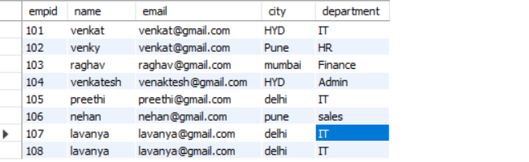
1.find duplicate records in a table (same name, email, city, department)
Select name,email,city,department,count(*)
From emp
Group by name,email,city,department
Having count(*) > 1
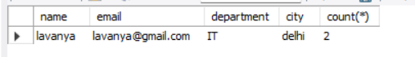
2.find duplicate record and delete duplicate record and keep original

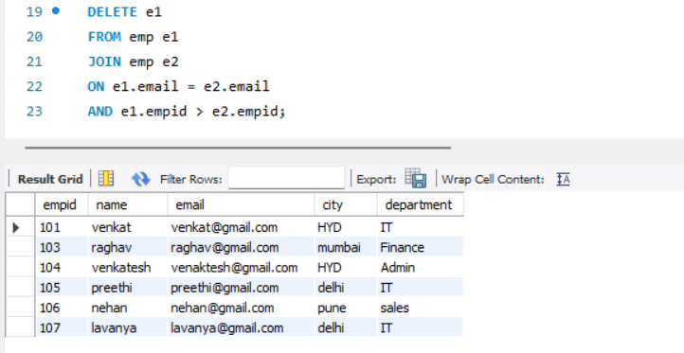

3.retrieve the 2nd highest sal from emp table.
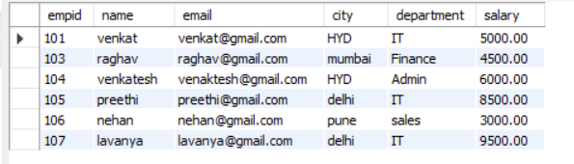
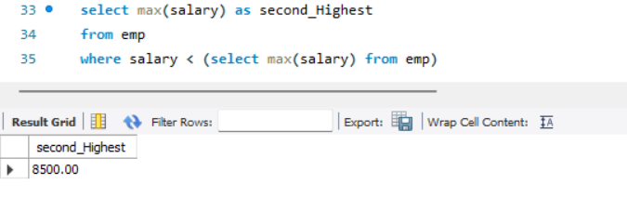
3rd highest salary
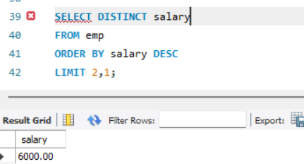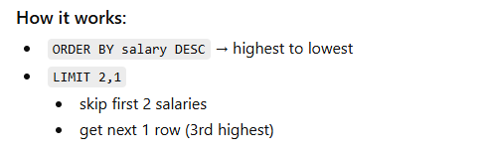
4.find employees without department(left join usage)
In single table:
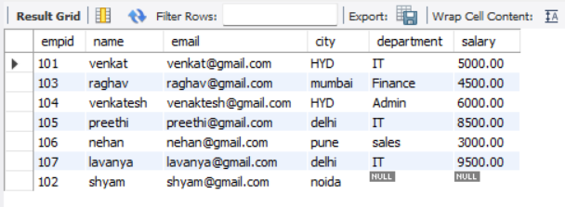
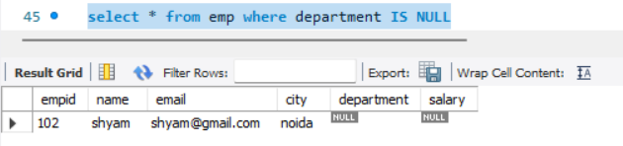
Now we have 2 tables emp1 and department , here we can use left join
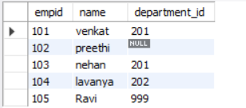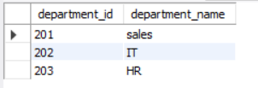
emp1 department
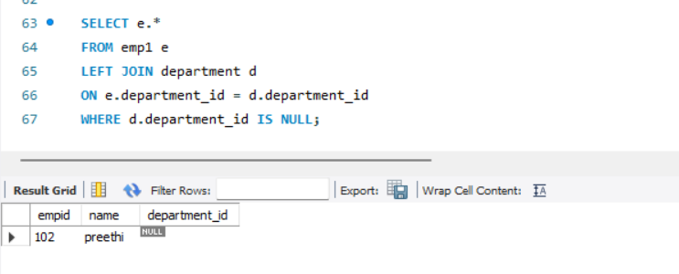
5.calculate the total revenue of the product
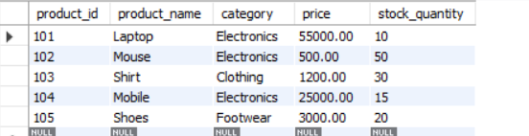
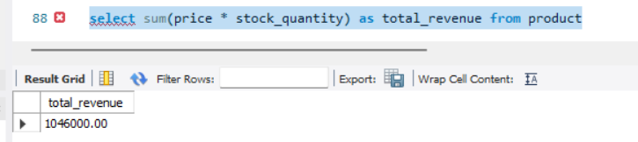

Calculate each product revenue:
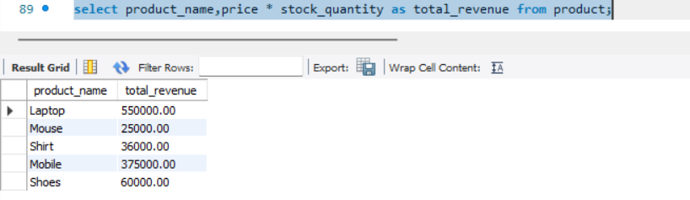
Calculate revenue based on category:
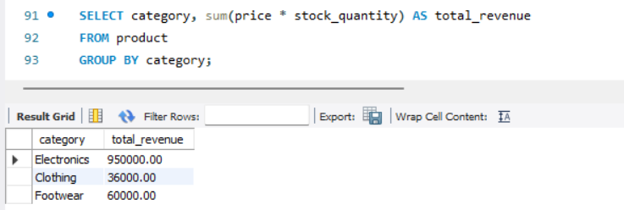
6. select top3 highest emp salaries
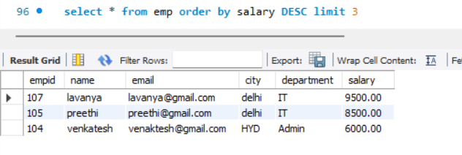
Here in my sql top is not working so we used limit
7.customer who made purchases but never returned products.
Customer table returns table
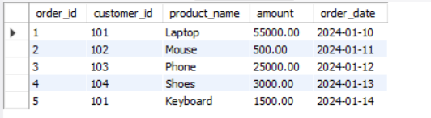
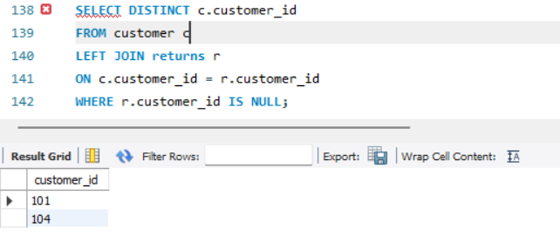
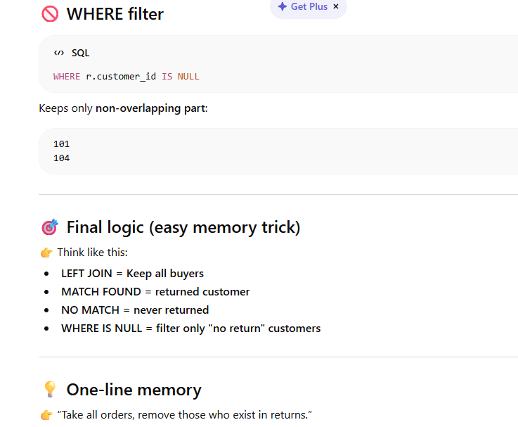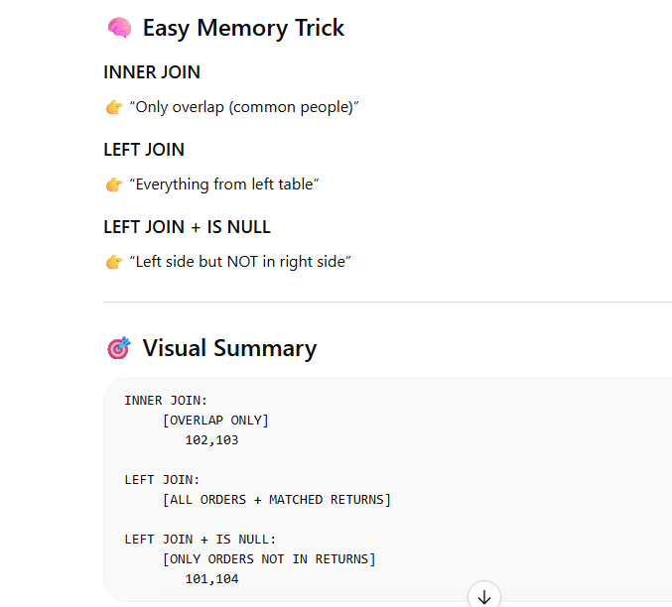
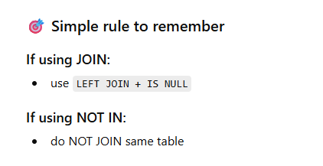
8.show the count of orders from customer
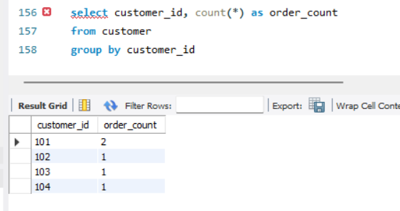
9.retreive all emp’s joined in 2023
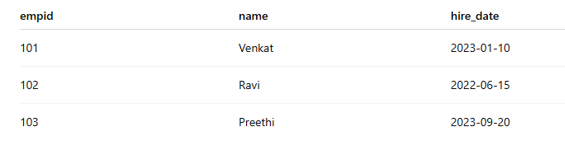
SELECT * FROM emp WHERE YEAR(hire_date) = 2023;
SELECT * FROM emp WHERE hire_date >= '2023-01-01'
AND hire_date < '2024-01-01';
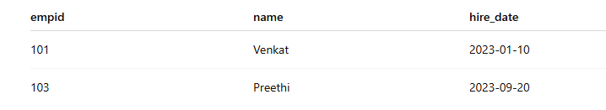

10.calculate average order value per customer
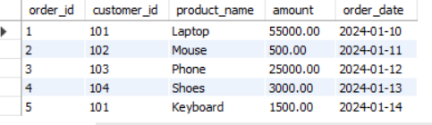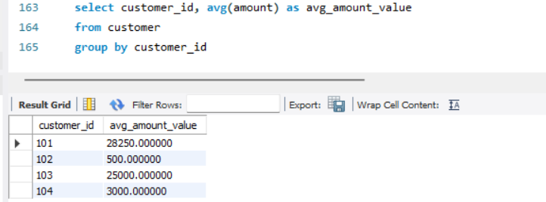
11.get the lastet order placed by each customer.
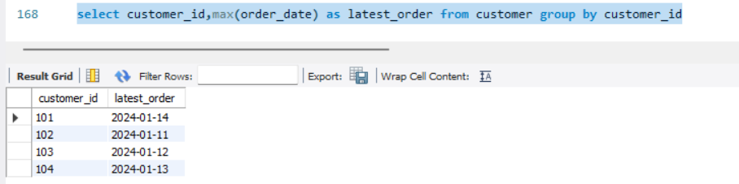
12. find products that were never sold
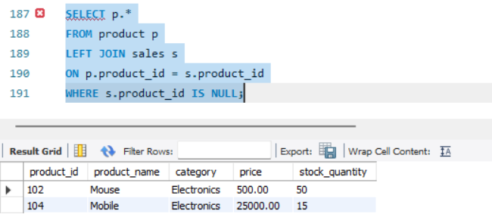
Suing subquery
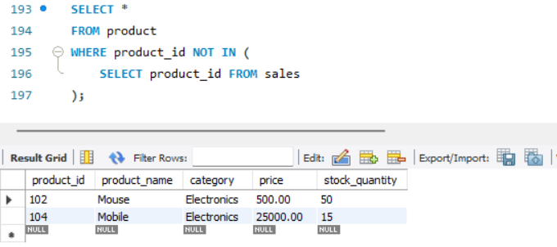

13.identify most selling product
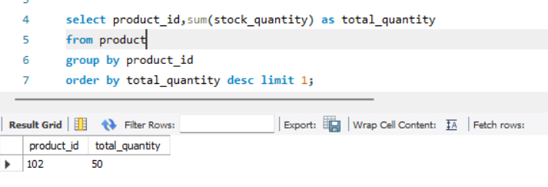
14.get the total revenue and the number of orders per region
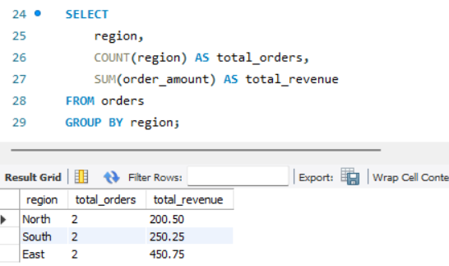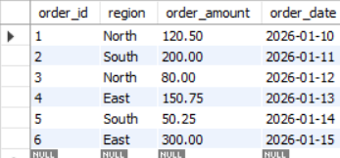
15.count how many customers placed more than 5 orders
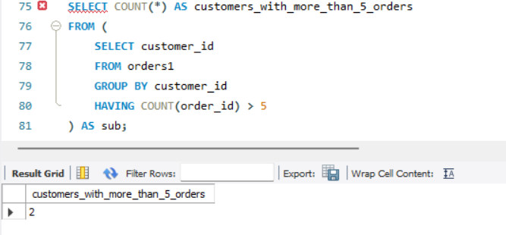

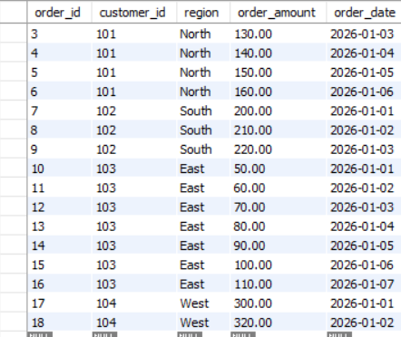
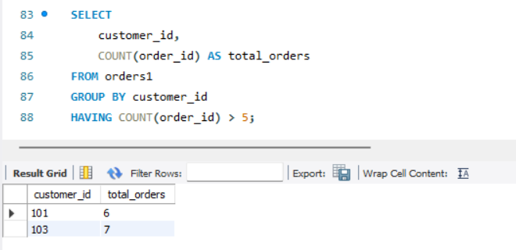
16.retreive customers with orders above the average order value
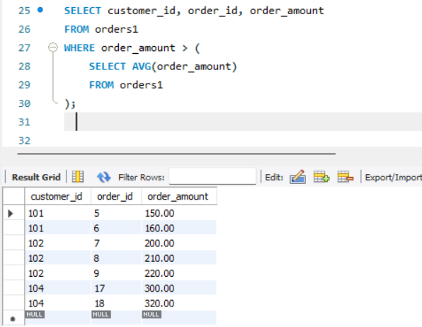
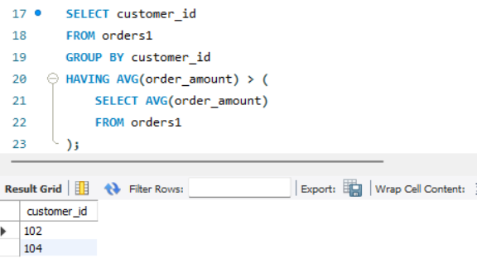

17. find all employees hired on weekends.
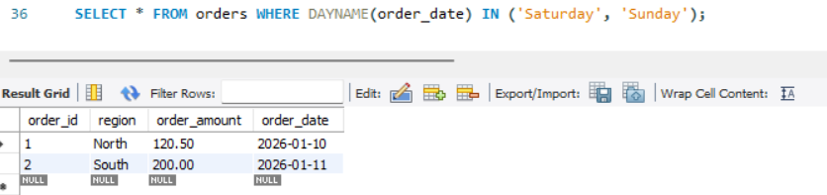
“How do you filter weekend records?”
Best answer:
Use weekday function (DATENAME or DAYNAME) and filter Saturday and Sunday, or use DATEPART logic depending on database.
18. find salary between 5000 to 10000
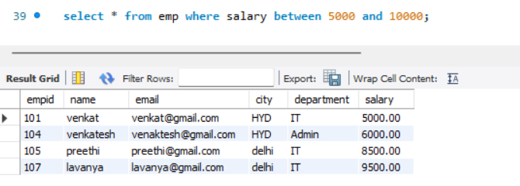

19.get monthly sales revenue and order count
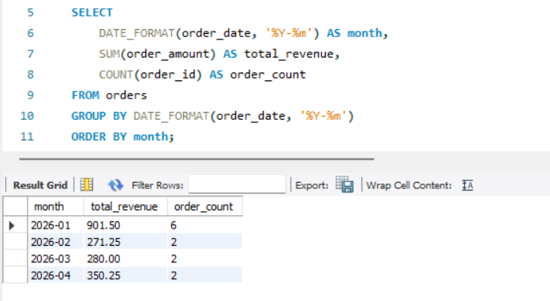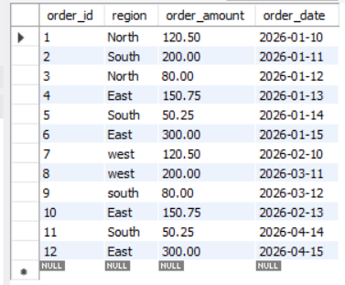
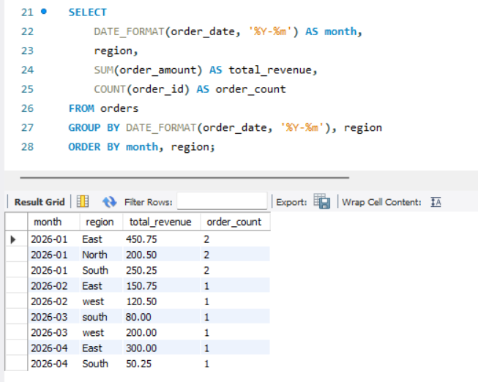
20.rank employees by salary witin each department
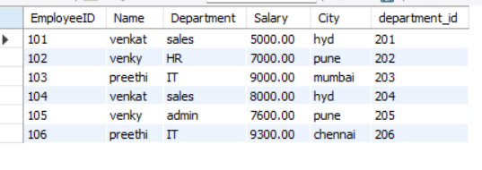
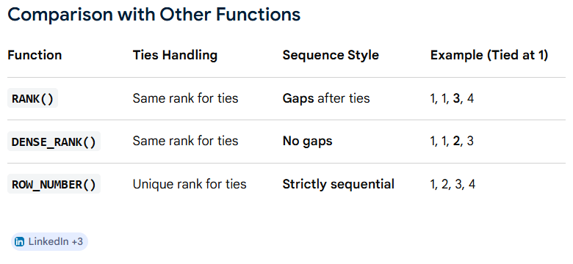
21. find customers who placed orders in every month in 2024.
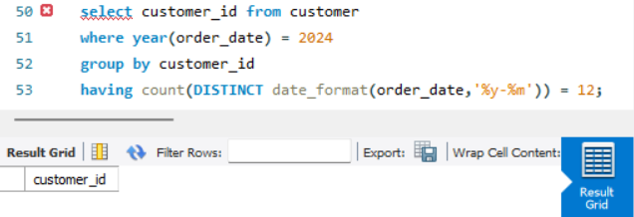
Result is empty because no one has ordered every month in 2023.
Customers who ordered in at least 3 months >3

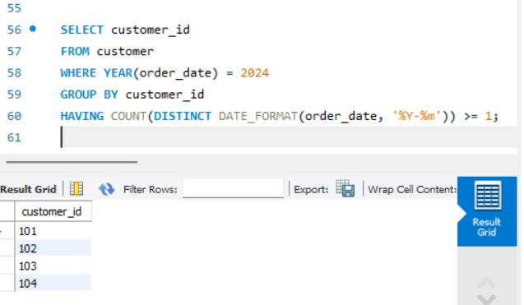

Customers with multiple orders (not month-based)
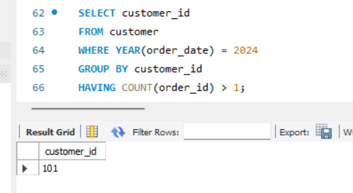
22.identify the 1st an d last order of each customer
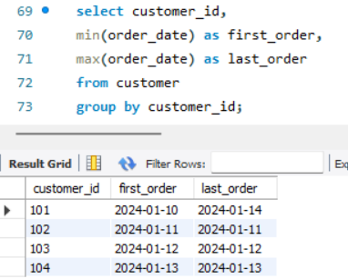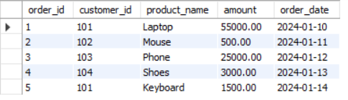
23.find movin average of sales over last 3 days
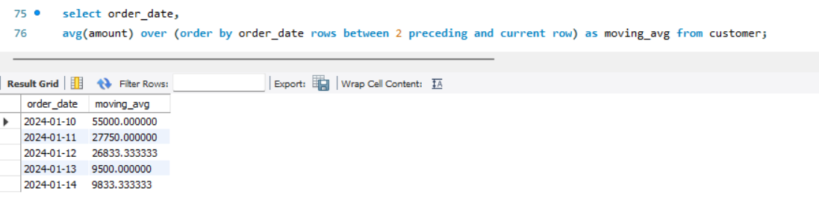
24.calculate cumulative revenue by date.
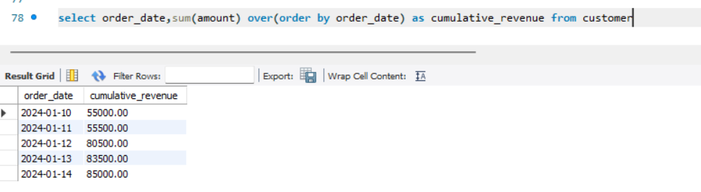
This query calculates a running total of amount sorted by order_date.
👉 For each row:
- It adds the current row’s amount
- Plus all previous rows (based on date order)
25. retreive the maximum salary difference within each department.
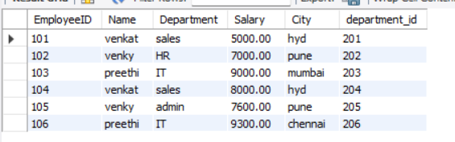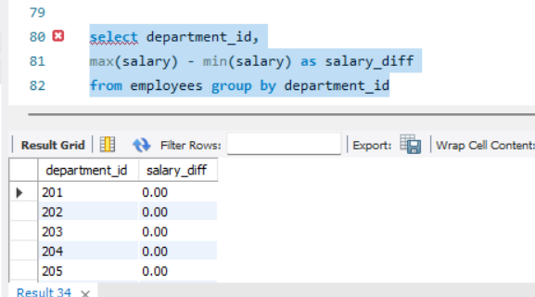
26.find the percentage of employees in each department
